Database Schema:

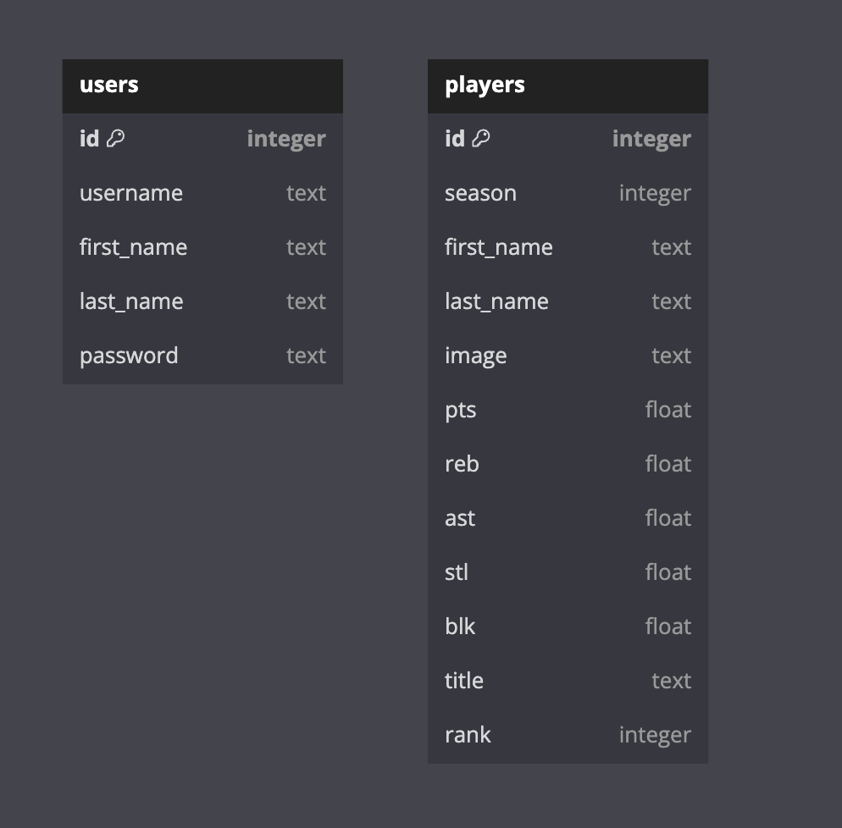

“users” table is used to store account information as an account is required to access most web application features

“players” table is used to store information on all players. There is a limit of 50 requests every 60 seconds for the API. Storing this information into our database will give us faster access to information needed to display more advanced statistics